C/C++ "Random Sentences" Lab Report

1) Enter your name, your student ID and date
Name: Jay Gupta
Student ID: 0961979
Date: 4/13/2020

PROJECT DESCRIPTION:
Write an application that uses random-number generation to create sentences. Use only five arrays of strings called article, adjective, noun, verb and preposition. All words in each array should use only lower-case letters. The length of each array should not be the same, and should be determined by the program when the program runs. Create a sentence by selecting a word at random from each array in the following order: article, adjective, noun, verb, preposition, article, adjective and noun. As each word is randomly picked, concatenate it to the previous words in the sentence with a space character separating each word. End each sentence with a period without a space character before the period. Code in the program needs to capitalize the first word instead of having a capital letter in the array of articles. The application must generate and display 20 sentences each time the program is run.
The article* array should contain at least the words "the", "a", "one", "some" and "any".
The adjective array could contain words like "brave", "orange", "fast", "slow", “smart”, etc.
The noun array could contain words like "boy", "girl", "dog", "town", "car", “truck”, “cat”, “bird”, “house”, etc.
The verb array could contain words like "drove", "jumped", "ran", "walked", "skipped", etc.
The preposition array should contain at least "to", "from", "over", "under" and "on".
*NOTE: Articles the, a and an are only used with singular nouns. Do not worry about selecting either 'a' or 'an' based on whether the next word starts with a vowel. The words some and any are actually classified as 'determiners' in the English language and can be used with plural nouns.
You can change or add additional nouns, adjectives, verbs and prepositions to the arrays. Make sure that your random picker looks at the array size for each type of part of speech.
Examples:
The brave dog skipped to a fast town.
The orange car jumped over a slow dog.
A fast girl walked to a brave girl.

SUMMARY OF LAB REQUIREMENTS:
* Use only five arrays with only lower-case letters ✔
* Different sizes for arrays ✔
* Article, adjective, noun, verb, preposition, article, adjective, noun ✔
* Space after each word, except the last word which is followed by a period ✔
* Two displays of 20 sentences each ✔
LAB REPORT:
2) Fill in the INPUT/PROCESSING/OUTPUT table (HIPO chart). Use either English or pseudo-code in the PROCESSING column. Do not paste code from your Visual Basic program.
INPUT | PROCESSING | OUTPUT
- None | - Declare & initialize an array for each part of speech.  - Find each array’s size.  - Declare variables, seed the random number generator.  - Create the 20-iteration for loop:  - Inside the for loop, get each part of speech, concatenating it to ‘sentence’.  - Capitalize the first letter of the sentence.  - Display the full sentence. | - 20 sentences in same part of speech order

DISCUSSION:
3) Complete the DISCUSSION section in English. It does not need to be long, but it needs to be complete.
3a) What did you do to develop the program?

First, I reviewed arrays and how they work. Then, I created the HIPO chart, and then started programming. As I went along, I reviewed what I forgot, and learnt what I didn’t know. For example, I was still unclear on how ‘time’ was used to have different numbers, or what seeding meant. I looked online for explanations and solutions. Finally, I tested the program repeatedly, checking to make sure that I fulfilled all project requirements.

3b) What problems did you have and how did you overcome the problems?

I had a problem with understanding why one puts char * when declaring the array. I looked online and asked you (the professor), and I have a basic idea. It is a pointer in memory, that makes it easy to reference when in the program. Other than that, the program was easy to conceptualize and program. \

PROGRAM OUTPUT:
4) Show two screenshots showing correct operation of the program. Refer to previous lab assignments to review how to save a screen shot to the lab report.
Sample program output #1 | Sample program output #2
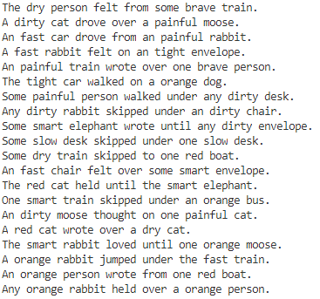 | 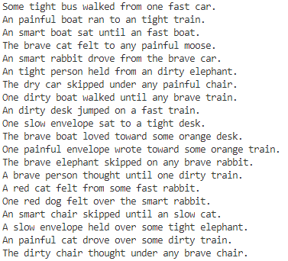

PROGRAM LISTING:
5) Copy and paste the code for the entire program.
/**
* Jay Gupta
* 4/13/2020
* C++_String_Manipulation.cpp (V1.0)
* Professor: Dan McElory
* Class: CIS 054
* Inputs:
* Outputs:
*/

#include <iostream> // cout and cin
#include <time.h> // time
#include <string> // C++ strings
using namespace std;

// arrays for each part of speech
const char * article[] = {"the", "a", "one", "some", "any", "an"};
const char * adjective[] = {"brave", "orange", "red", "fast", "slow", "smart", "painful", "tight", "dry", "dirty"};
const char * noun[] = {"desk", "person", "chair", "envelope", "car", "train", "bus", "boat",
"elephant", "dog", "cat", "moose", "rabbit"};
const char * verb[] = {"drove", "jumped", "ran", "walked", "skipped", "wrote", "thought", "loved", "held", "felt", "sat"};
const char * preposition[] = {"to", "from", "over", "under", "on", "toward", "until"};

// find each array's size
int articleCount = sizeof(article) / sizeof(char*);
int adjectiveCount = sizeof(adjective) / sizeof(char*);
int nounCount = sizeof(noun) / sizeof(char*);
int verbCount = sizeof(verb) / sizeof(char*);
int prepositionCount = sizeof(preposition) / sizeof(char*);

int main() {
// seed the random number generator
srand((unsigned int) time(0)); // in order to have different random numbers each time

// Declare Variables
string sentence;

// 20 sentences, 1 each iteration
for (int i = 0; i < 20; i++) {
// reset sentence each time
sentence = "";

string firstArticle = article[rand() % articleCount];
sentence += firstArticle + " ";

string firstAdjective = adjective[rand() % adjectiveCount];
sentence += firstAdjective + " ";

string firstNoun = noun[rand() % nounCount];
sentence += firstNoun + " ";

string onlyVerb = verb[rand() % verbCount];
sentence += onlyVerb + " ";

string onlyPreposition = preposition[rand() % prepositionCount];
sentence += onlyPreposition + " ";

string secondArticle = article[rand() % articleCount];
sentence += secondArticle + " ";

string secondAdjective = adjective[rand() % adjectiveCount];
sentence += secondAdjective + " ";

string secondNoun = noun[rand() % nounCount];
sentence += secondNoun + ".";

// capitalize first letter of string
sentence[0] = toupper(sentence[0]);

// display sentence
cout << sentence << endl;
}

return 0;
}

